# NonProfit Impact Hub

**Course:** INFO8003 – Systems Concepts, Analysis and Design  
**Project:** Final Major Project – Developing a Business System  
**Team Members and Roles:**

* **Team Lead / Business Model Developer, Use Cases, Documentation & Product Owner:** Musakan
* **UI/UX Designer / Market Analysis, Content Plans & Prototype Mockups:** Gurpreet Singh
* **Developer / ERD, Class Diagram, Code Development, Testing & Scrum Master:** Neha Bhagat

**Table of Contents**

**1. Introduction**

**• Project Overview**

**• Objectives**

**• Importance of the Project**

**2. Using a collaborative tool**

**3. Forming a Development Team**

**4. Preliminary Research**

**5. Brainstorming & Idea Development**

**6. Market Research & Analysis**

**7. Application Description & Goals**

**8. Technical Requirements**

**9. User Personas**

**10. Use Cases & Activity Diagram**

**11. Entities**

**12. Content Plans & Prototypes**

**13. Class Diagram & System Design**

**14. Implementation & Agile Plan**

**15. Presentation**

**16. Final Report**

**Conclusion**

**References**

**Introduction**

The introduction sets the scene for the reader and gives a summary of your project. It consists of:

**1.Project Overview**

In order to solve social, environmental, and humanitarian issues, nonprofit organizations are essential. But a lot of NGOs have trouble keeping track of contributors, organizing volunteers, managing events, submitting grant applications, and accurately assessing their impact. Our team is creating a Nonprofit Organization Management System, a digital platform intended to improve overall efficiency and streamline nonprofit operations, in order to address these issues.

Features like these are integrated into our system:

• Event management: Resources for planning, scheduling, and advertising events.

• Volunteer Coordination: A single location for scheduling, recruiting, and communicating volunteers.

• Donor Tracking: A module for donor relationship management that keeps track of donations, provides receipts, and sends customized messages.

**2. Objectives**

This project's main goals are to:

1. Increase Operational Efficiency: Offer a centralized platform for managing important nonprofit initiatives with little in the way of administrative burden.

2. Boost Volunteer Engagement: Provide a user-friendly volunteer management system that makes task allocations, scheduling, and recruitment easier.

3. Improve Donor Relations: To improve donor retention, monitor donor interactions, automate acknowledgments, and offer insights.

4. Optimize Grant Management: Provide a structured application procedure to assist NGOs in finding, applying for, and monitoring funds.

**3. Importance of the project**

Limited funding, antiquated technology, and ineffective procedures make it difficult for nonprofits to manage their operations. Our initiative tackles these issues by offering a creative, AI-powered solution that is customized to meet customer requirements**.**

**Key reasons why this project is important**

• Fills a Need: A lot of the nonprofit management products on the market today are pricey, unduly complicated, or unintegrated. Our platform offers an all-in-one, reasonably priced solution.

• Encourages Entrepreneurship and Sustainability: Nonprofits can increase their operational efficiency, draw in more capital, and maintain their influence over time by simplifying their processes.

• Promotes Innovation: Our platform brings cutting-edge solutions to the charity industry by leveraging automation, cloud-based technology, and AI-driven analytics.

• Increases Community Impact: In order to meet societal demands, nonprofit organizations are essential. Our project indirectly supports larger social change by enhancing their management systems.

**Forming a Development Team**

This development team role chart outlines the roles of the team working on the management system project for your nonprofit. This diagram effectively divides responsibilities across tasks and Scrum roles, assuming a three-person team.

**Development Team Role Chart**

|  |  |  |
| --- | --- | --- |
| **Team Member** | **Assigned Tasks** | **Scrum** |
| **Member 1: Muskan (Team Lead)** | -Brainstorming -Business- Use Cases - Testing (Unit, Integration) | **Product Owner** |
| **Member 2: Gurpreet Singh (UI/UX Designer)** | -Research – Market Analysis and Personas -Prototype Mock-ups -Content Plans - Documentation | **Scrum Master** |
| **Member 3: Neha Bhagat** | -ERD (Entity Relationship diagram) – Class Diagram – Use cases – Code Development – Testing (Regression, Acceptance, Usability | **Development**  **Team** |

**Preliminary Research**

1. **Research Subjects Addressed**

We conducted study on the following subjects in order to create a robust nonprofit management system:

**A. Nonprofit Entrepreneurship**

• How NGOs strike a balance between social effect and financial viability.

• Difficulties with grant acquisition, donor retention, and fundraising. • the contribution of technology to increased operational effectiveness.

**B. Nonprofit Sustainability**

• Long-term financial stability tactics (e.g., recurring contribution, donor engagement).

• Digital fundraising and environmentally responsible event planning to cut down on waste.

• How AI may improve impact by allocating resources optimally.

**C. Nonprofit Facilities Planning**

• Tools for scheduling and managing volunteers.

• Setting aside space for community engagement and live activities.

• Using cloud-based solutions to facilitate distant collaboration.

**D. Development Paradigms**

• Pair Programming: Beneficial for developing core features like donation tracking.

• Mob Programming: Ideal for collaborative brainstorming and prototyping

• Test-Driven Development (TDD): Ensures system reliability, particularly in financial transactions.

**2. AI-Powered Research Prompts & Adjustments**

Below are the AI prompts we used and the modifications we made:

Prompt 1:

What are the biggest challenges nonprofits face in event management, volunteer coordination, and fundraising?”

✅ Adjusted AI Response:

• AI initially focused on general business challenges. We refined it to nonprofit-specific issues like donor retention, volunteer burnout, and compliance with grant requirements.

Prompt 2:

How can AI tools improve management in nonprofit organisations?

✅ Modified AI Reaction: AI recommended chatbots powered by AI, but we prioritised automated grant writing support and predictive analytics for donor trends.

Prompt 3:

What are the best methods for organising a nonprofit event that is sustainable?

✅ Modified AI Reaction: AI offered a combination of business and nonprofit event planning techniques. We emphasised low-cost event venues and web fundraising while eliminating corporate-focused elements.

Prompt 4:

Describe the advantages of test-driven development (TDD) for nonprofits' financial transaction systems.

✅ Modified AI Reaction: AI encompassed general banking applications. We updated it to emphasise fraud prevention and donor security in the handling of nonprofit finances.

1. **Synopsis of Results**

• To effectively handle volunteerism, grants, and donor connections, nonprofits require automation technologies.

• AI-powered insights can enhance fundraising success by predicting donor behaviour.

• Eco-friendly campaigns and digital events are examples of sustainable practices that are becoming more and more popular.

• Scrum and TDD, two agile approaches, guarantee excellent development with few mistakes.

**Brainstorming**

1. **Determining the Fundamental Issue**

• Ineffective event management:

which involves manually keeping track of volunteers, participants, and timetables.

• Volunteer Coordination Problems:

Having trouble allocating responsibilities, keeping track of hours, and controlling availability.

• Difficulties with Donor Tracking:

Insufficient knowledge about donor engagement and retention tactics.

• Difficult Grant Application Process:

Prolonged writing, research, and submission.

• Limited Impact Reporting:

It might be challenging to gauge and demonstrate an initiative’s effectiveness**.**

1. **The Nonprofit Management System is our solution.**

In order to forecast donation trends, we suggest a cloud-based charity management system that incorporates:

• AI-powered insights into donor involvement.

• Automated matching of volunteers according to availability and skill sets.

• Tools for event administration that make RSVPs, tickets, and scheduling simple.

• A smart grant assistant that uses AI-powered suggestions to expedite applications.

• Impact analytics dashboard to report on nonprofit success in real time.

1. **Essential Elements**

✅ Volunteer Coordination Module:

AI-powered volunteer-task matching; time monitoring and certification creation; interaction with availability calendar

✅ Event Management System; Volunteer job assignment;

Online event registration and ticketing; Budget monitoring and sponsorship administration

✅ Donor & Fundraising Platform;

AI-driven insights for donor retention; automated social media and email campaigns; and tracking and setup for recurring donations

✅ Grant Application Hub

• AI-driven grant eligibility checker

• Application progress monitor

• Submission document repository

1. **What Makes Our App Unique**

• AI-Powered Efficiency: Automates important tasks, such as grant writing, donor insights, and volunteer matching.

• All-in-One administration: Our app incorporates all essential nonprofit operations, in contrast to other systems that solely concentrate on event or fundraising administration.

• User-Friendly Interface: Easy to use for nonprofits with little experience with technology.

• Cloud-Based Collaboration: Teams, volunteers, and donors can access it from any location.

**Research – Web Market Analysis**

To handle tasks like event planning, volunteer coordination, donation monitoring, grant applications, and impact reporting, nonprofit organisations frequently use specialised software. There are numerous all-inclusive methods to help in these areas.

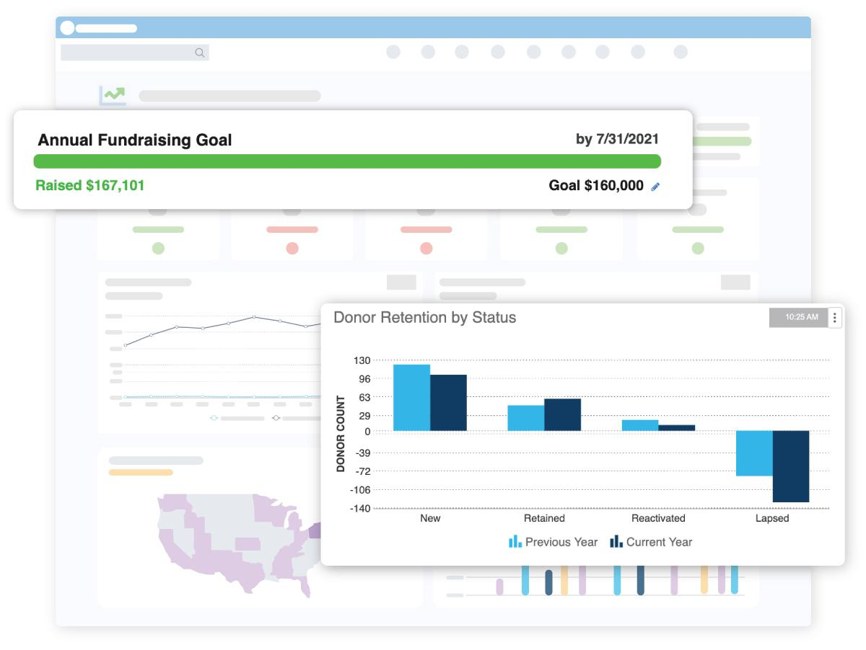**Current Nonprofit Management Software:**

• Blackbaud Raiser's Edge NXT: A cloud-based program that provides analytics, fundraising, and donor management capabilities.

• Bloomerang: Offers resources for engagement and fundraising, with an emphasis on donor management and retention. <https://bloomerang.co/blog/nonprofit-software/>?

• Aplos: Developed for churches and NGOs, it provides capabilities for donation management, fund accounting, and compliance. <https://softwareconnect.com/roundups/best-nonprofit-software/>?

**Applications in Similar Market**

• Salesforce Nonprofit Cloud: Helps with program administration and fundraising by offering CRM features designed specifically for NGOs.

• NeonCRM: Provides capabilities for membership, management, event planning, and donor management. <https://www.g2.com/categories/nonprofit/>?

**Existing Approaches to Similar Objectives:**

Smaller NGOs use Google Sheets or Microsoft Excel for simple data collection and reporting.

Mailchimp: Helps with donor communications and email campaign management.

**Features Your App Must Have:**

Plan, advertise, and oversee events with ease using the platform's integrated event management feature. https://www.charitycharge.com/nonprofit-resources/nonprofit-software/?

• All-inclusive Volunteer Coordination: efficiently plan, monitor, and interact with volunteers. https://www.zoho.com/creator/industries/nonprofits-organization-management-software.html?

• Advanced Donor Tracking: Keep tabs on contributions, preferences, and interactions with donor.

• Effective Grant Application Management: Make it easier to find, apply for, and monitor grants.

• Comprehensive Impact Reporting: Produce reports that highlight the accomplishments and influence of the organisation.

**Differentiation from Existing Apps:**

• Unified Platform: Consolidating all necessary functionalities into a unified, intuitive user interface.

• Customisation: Enables businesses to modify the program to meet their unique requirements without requiring a high level of technical expertise.

• Affordability: Providing an economical option without sacrificing necessary features.

**Rationale for Development:**

The creation of this app answers the need for a comprehensive, adaptable, and reasonably priced solution for nonprofits. The app can boost stakeholder participation, operational efficiency, and the overall impact of nonprofit activities by consolidating essential features into a single platform.

**Description**

An AI-enhanced cloud-based platform called the Nonprofit Organisation Management System (NOMS) was created to help organisations run their businesses more effectively. It offers a one-stop shop for managing grant applications, organising volunteers, tracking donors, organising events, and reporting on results. The technology helps charitable organisations increase fundraising efficiency, decrease administrative hassles, and improve operational transparency by combining automation, AI analytics, and cloud storage. The platform's user-friendly design allows it to serve organisations of all kinds, from small local charities to major worldwide nonprofits, by providing both web and mobile access. Its objectives are to increase the impact of social programs, optimise donor interaction, and streamline processes.

**Business and Social Purpose**

**• Business purpose:**

*By automating administrative processes, it helps charity organisations run more effectively.

*Enhances fundraising tactics by using predictive analytics and AI-driven donor insights.

*Improves financial management with tools for grant management and transparent donor tracking.

*Simplifies impact reporting and volunteer coordination, which lowers overhead expenses.

**• Social Purpose:**

*Facilitates volunteer recruitment and event participation to promote increased community involvement.

*Enhances trust between donors and charities by increasing fund allocation transparency.

*Offers improved decision-making resources to organisations so they may maximise their social impact projects.

*Provides tools for managing grant applications to assist NGOs in more efficiently obtaining financing.

**Preliminary List of Preferred Features**

1. Event Management Module: Plan and coordinate volunteer activities, awareness campaigns, and fundraising.

2. Volunteer Coordination System: Monitor volunteer availability, delegate work, and oversee involvement.

3. Donor Management & CRM: Send customised engagement emails, keep track of contributions, and manage donor profiles.

4. Grant Application Tracking: Find appropriate funds, handle applications, and monitor the status of funding.

5. Impact Reporting & Analytics: Produce thorough reports on the results of donations, volunteer work, and event success.

6. AI-Driven Insights & Suggestions: Examine donor patterns, provide the best fundraising recommendations, and enhance event organisation.

7. Mobile Application: Allow donors and volunteers to interact with the nonprofit while they're on the go.

8. Automatic Tax Receipts and Compliance: Produce donation receipts and make sure all legal criteria are met.

**Possible Sources of Income**

1. Subscription Model: Basic, Pro, and Enterprise feature tiers are available as monthly or yearly subscriptions.

2. Transaction Fees on Donations: A little percentage charge for contributions made via the website.

3. Corporate Sponsorships & Advertising: Collaborations with companies that assist nonprofit organisations.

4. Premium Customisation Services: Providing major organisations with specialised features and integrations.

5. AI-Powered Fundraising Insights: Offering exclusive access to donor and fundraising data powered by AI.

6. White-Label Solutions: Granting platform licenses to other businesses in need of a unique nonprofit administration solution.

**Future Objectives**

1. Blockchain Integration for Donation Transparency: Blockchain technology is used to track donations and guarantee fund distribution transparency.

2. AI-Powered Chatbots for Volunteer & Donor Engagement: Using intelligent chatbots to assist donors, answer frequently asked questions, and mentor volunteers.

3. Integration of social media and Crowdfunding: This allows NGOs to use social media platforms to directly solicit funds and promote initiatives.

4. Automated Grant Writing Support: AI-driven resources to assist NGOs in creating strong grant proposals.

5. Extension to Government & CSR Sectors: Modifying the system to accommodate corporate social responsibility (CSR) projects and government assistance programs.

6. AI-powered solutions that forecast donor behaviour and enhance fundraising tactics are known as advanced predictive analytics for fundraising.

7. Global Outreach & Localisation: This feature allows NGOs from all over the world to use the platform by supporting a variety of languages and currencies.

**Technical Requirements**

**Special Device Hardware Features**

For the charity organisation management app to improve accessibility, usability, and functionality, certain hardware components would be needed. Key device hardware requirements are as follows:

1. **A camera**

• Document Scanning: Take note of and upload event forms, donation receipts, and grant applications.

• QR Code and Barcode Scanning: Used for monitoring donations, event access, and volunteer check-ins.

• AI-Powered Image Recognition: Examine receipts to automatically track donors and prepare tax returns.

**2. Location & GPS Services**

• Volunteer & Event Tracking: Displays event locations and volunteer opportunities in the area.

• Geofencing: Notify volunteers when they enter or depart event sites.

• Route optimisation: Help volunteers find their way to locations for events or places to drop off donations.

**3 • NFC (Near Field Communication)**

• Tap-to-Check-In: At events, volunteers and donors can use their phones to tap an NFC tag to check in.

• Contactless Donations: Tap-to-pay contributions using mobile payment systems are supported.

1. **Authentication via Biometrics**

**\*** Nonprofit administrators who handle sensitive donor and financial data can log in securely using fingerprint and facial recognition.

• E-Signatures: Use biometrics to authenticate agreements and grant applications.

1. **Bluetooth Interaction**

• Wearables Integration Connect smartwatches to track volunteers in real time and send out event reminders.

• External Hardware Support: Create event passes or donation receipts by connecting to Bluetooth printers.

**Special Input Controls**

To enhance usability, productivity, and accessibility for users overseeing nonprofit operations, the application will integrate a number of unique input features. These consist of:

1. Smart & Dynamic Forms

• Auto-Fill & AI Suggestions: Utilise past entries to pre-fill grant application areas, event details, and donor data. Forms that dynamically adapt to user inputs (e.g., burying unimportant fields) are known as conditional fields.

• Error Detection & Validation: To avoid submission errors, real-time validation is provided for fields such as tax IDs, phone numbers, and email addresses.

1. AI Support & Voice Commands

• Voice-Activated Navigation: Voice commands, such as "Schedule a volunteer event on Friday," can be used to interact with the app.

• AI-Powered Chatbot: A virtual assistant to aid with volunteer coordination, event planning, and donor monitoring.

1. Drag-and-drop Capabilities

• Task Assignment: Volunteers can be dropped into open event slots by organisers.

• Event Planning Board: Utilise an interactive Kanban-style interface to create and modify event schedules.

1. Scan Barcodes and QR Codes

• Event Check-In: Volunteers and guests can quickly register at events by scanning a QR code.

• Digital Receipts for Donations: To record contributions and produce tax deduction returns, scan receipts. 5. Controls Based on Touch and Gestures

• Swipe Actions: Fast steps to confirm volunteer shifts or approve grant applications.

• Pinch-to-Zoom: This feature makes it simple to view documents and maps for grant tracking and event locations.

**Context-Based Constraints & Advantages**

The management system for nonprofit organisations will function in a variety of real-world scenarios, each with its own set of advantages and limitations. An examination of these factors is provided below:

**1. Limitations Based on Context**

a) Accessibility & Internet Connectivity

• Limitation: Real-time updates and cloud-based functionality may not be available to users in distant or poor locations due to inadequate or non-existent internet access.

• Fix: Put in place offline mode, which allows data to sync as soon as the user is connected again.

b) Device Performance & Compatibility

• Limitation: Volunteers and nonprofit organisations may utilise outdated technology with constrained storage and processing capacity.

• Solution: Provide a lightweight version of the software with the necessary features, optimising it for lower-end smartphones.

c) Data privacy and security

• Restrictions: Managing private donor information, financial transactions, and volunteer details necessitates adherence to laws (such as GDPR and HIPAA for nonprofits involved in health care).

• Solution: Make use of secure authentication techniques (such multi-factor authentication), role-based access, and encryption. d) Cultural and Multilingual Adaptation

• Restrictions: International nonprofits work in many locales with various linguistic and cultural standards.

• Solution: Offer culturally aware UI/UX design and multilingual assistance.

e) Issues with Real-Time Coordination

• Limitation: Coordinating volunteers, organisers, and donors in a seamless manner is essential for large-scale nonprofit events.

• Fix: Use push notifications and SMS alerts to assign tasks, schedule events, and provide real-time notifications.

1. **Advantages Based on Context**
2. Collaboration via the Cloud

• Benefit: Cloud storage ensures accessibility across devices and locations and facilitates easy data sharing across teams.

• Advantage: Facilitates remote collaboration for nonprofit employees and volunteers.

1. GPS integration and location-based services

• Benefit: GPS tracking enables donations to find nearby charitable initiatives and volunteers to locate events in their area.

• Advantage: Increases participation by facilitating access to charitable endeavours.

1. Automation and AI Capabilities

• Benefit: AI-powered analytics can automate repetitive administrative duties, forecast donor behaviour, and suggest fundraising tactics.

• Advantage: Less manual labour means organisations can concentrate on projects that have a bigger impact.

1. Integration with Third-Party Tools and Scalability

• Benefit: Social media networks, CRM systems, and payment methods can all be integrated with the app.

• Advantage: Improves communication and increases fundraising opportunities.

**Personas**

The target market for the Nonprofit Organisation Management System is represented by the following three different persona descriptions:

**Persona 1: Camila- The Nonprofit Director**

**Age:** 41

**Occupation:** Executive Director of Helping Hands Foundation

**Location:** Chicago, IL

**Tech Savviness:** Moderate

**Pain Points:**

*Struggles to coordinate several fundraising events and manage volunteers.

*The tracking of grant applications and donor donations needs to be done effectively.

*Prefers a system that combines reporting, event planning, and donor relationship management.

**Goals & Needs:**

• A centralised system for organising events, maintaining volunteer records, and managing donor databases.

• Financial tracking and impact analytics in real time for reporting needs.

• A grant administration tool that simplifies deadlines and application tracking.

**How the App Helps:**

• offers a single dashboard for managing volunteers and events. • Automates the grant submission and donor tracking procedures.

• creates impact reports in real time for stakeholders and board meetings.

**Persona 2: Friedrich – The Dedicated Volunteer**

**Age**: 28

**Occupation**: Marketing Specialised & weekend Volunteer

**Location**: Austin, TX

**Tech Savviness**: High

**Pain Points**:

• Struggles to sign up for assignments and keep track of volunteer scheduling.

• Wants to interact with organisers and acquire event details with ease.

• Prefers platforms with real-time notifications that are mobile-friendly.

**Goals & Needs:**

• An easy-to-use portal that provides mobile access to forthcoming volunteer opportunities.

• The ability to log volunteer hours, register for shifts, and get event reminders.

• Social media tools for exchanging experiences and interacting with other volunteers.

**How the App Helps:**

• Makes it simple to sign up for events and volunteer shifts.

• Offers push alerts for updates and reminders.

• Offers a message function for direct contact with employees of nonprofit organisations.

**Persona 3: William Louis -The Philanthropic donor**

**Age:** 55

**Occupation:** Small Business owner & community Leader

Location: Miami, FL

**Tech Savviness**: Low to moderate

**Pain Points**:

• Prefers a straightforward donation procedure devoid of intricate processes

•wants clarity regarding the utilisation of gifts.

• Requires financial reports and tax-deductible receipts for documentation.

**Goals & Needs:**

• Several payment alternatives and a smooth, safe donation process.

• Real-time impact updates on the use of contributions.

• Tax-deductible receipts that are automatically generated for financial monitoring.

**How the App Helps:**

• Shows impact measurements and success stories in real time; • Offers a smooth contribution tool with several payment alternatives.

• Provides yearly donation summary and automated receipts for tax filing.

**Use cases**

Here’s how to approach the use cases part of your Nonprofit organisation Management system:

**Use Case List**

The app's primary use cases are listed below, arranged by functionality:

1. **Event Management**

• Organise Event: An administrator or planner plans an event, including the date, venue, and goal.

• Edit Event: Change the specifics of an already-existing

event.

• Register for Event: Participants or volunteers register for an event.

• Monitor Event Attendance: The system keeps track of who showed up for an event.

1. **Organising Volunteers**

• Volunteer Application: New users fill out an application to volunteer.

• Authorise Volunteer: The administrator examines and accepts or denies volunteer applications.

• Assign Volunteer to Event: Based on roles, organisers assign volunteers to particular events.

• Monitor Volunteer Hours: For documentation and acknowledgement purposes, the system keeps track of volunteer hours.

1. **Fund & Donor Administration**

• Make a Donation: Contributions are made online by donors. • Generate Donation Receipt: For tax purposes, the system generates and emails a receipt.

• View Donation History: This feature allows donors to view their previous contributions.

1. **Reporting & Grant Applications**

• Submit Grant Proposal: Administrators apply to funding organisations for grants.

• Monitor Grant Status: The grant application's status is updated by the system.

• Generate Impact Reports: The system generates reports that detail the expenditure of monies.

1. **Interaction & Communication**

• Post Announcements & Updates: Administrators can notify contributors and volunteers of news and updates.

• Send alerts: To remind users of events, updates, and deadlines, the system automatically sends out emails or push alerts.

• Message Donors and Volunteers: Administrators have the ability to message users directly.

**Use Case Diagram**

This is the Nonprofit Organisation Management System use case diagram. The primary actors (Admin, Volunteer, Donor) and their interactions with important system features are graphically represented.

**Use Case Descriptions**

There are two interesting use cases with comprehensive descriptions from the list:

1. **Assign the volunteer to one or more event**

**Actors:** Admin

**Description:** The administrator allocates authorised volunteers to designated positions during an event. The system sends confirmation alerts and verifies volunteers meet eligibility requirements.

**Steps:**

1: From the event list, the administrator chooses an event. 2. The administrator looks at the volunteer list.

3. Volunteers are chosen by the administrator and given roles for the event.

4. The system proposes volunteers based on event needs, rather than just verifying their talents.

• If a volunteer is unavailable, the system provides alternatives.

5. The volunteer's schedule is updated by the system.

6. Assigned volunteers receive notifications from the system.

**Alternative Routes:**

• The system recommends other routes in the event that a volunteer is not available.

• The system alerts the volunteer whenever an administrator eliminates an assignment.

• When an administrator removes a volunteer from an event, the system notifies both the volunteer and suggests a replacement.

1. **Produce Actor Impact Reports**

**Actors:** Donor, Admin (View Only)

**Description**: To create reports on nonprofit operations and impact, the system gathers volunteer and financial data.

**Steps**

1: The administrator chooses the report's time frame.

2. The system retrieves pertinent information (volunteer hours, events, and donations).

3. Instead of just generating a report, the system can enable administrators to customise report fields (for example, donations by campaign, volunteer hours per event).

4. The report can be shared with stakeholders or exported as a PDF by the administrator.

5. Public reports are available to donors via their dashboards.

**Alternative Routes:**

• Admins can filter reports by particular programs or funding sources; the system alerts them if no data is available.

If there is no data for a specific time frame, the system offers the next closest accessible period rather than just alerting administrators.

**Activity Diagram**

I'll make two activity diagrams based on use cases for a nonprofit organisation management system.

**Volunteer Registration**

The procedure where a user (volunteer) registers to take part in an event is modelled in this diagram.

**Flow of Activity:**

1. The user goes to the page where volunteers can register. 2. The user enters their event choices and personal information.

3. The system verifies the input.

• The user is prompted to fix problems if they are invalid. 4. The registration form is turned in by the user.

5. The system saves volunteer information.

6. The system emails a confirmation.

7. The registration process is finished**.**

**Donor Contribution**

The procedure by which a contributor contributes to the organisation is depicted in this diagram.

**Flow of the Activity:**

1. The donor goes to the donation page.

2. The donor inputs a custom amount or chooses a donation amount.

3. The donor gives payment information.

4. Payment is processed by the system.

• The donor is asked to try again if the first attempt fails.

5. A donation receipt is sent by the system.

6. The database contains a record of the donation.

7. The procedure is finished.

Key Takeaways:

• Volunteer Registration ensures a structured onboarding process for new volunteers.

• Donor Contribution ensures seamless and secure donation processing.

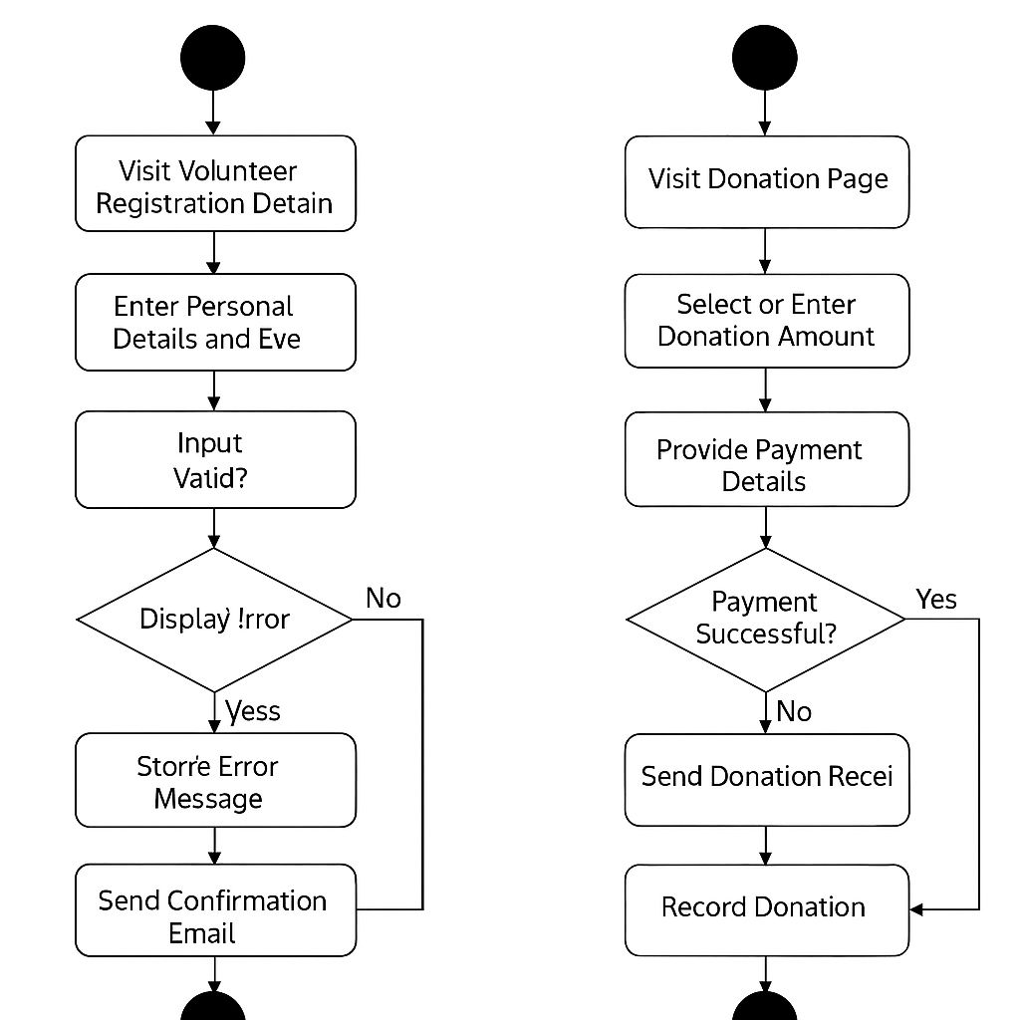

**Key Takeaways:**

• Volunteer Registration ensures a structured onboarding process for new volunteers.

• Donor Contribution ensures seamless and secure donation processing.

**Entities**

**Business Entities & Attributes**

A list of important business entities and their attributes for the Nonprofit Organisation Management System may be found below.

|  |  |
| --- | --- |
| **Entities** | **Attributes** |
| **User** | Name, Email, Phone, Role (Admin, Volunteer, Donor), Password, User ID (PK), and Volunteer Registration Date. |
| **Event** | Event ID (PK), Title, Description, Date, Capacity, and Status (Completed, Ongoing, or Upcoming). |
| **Volunteer Assignment** | Task, Status (Assigned/Completed), Volunteer ID (FK), Event  ID (FK), Assignment ID (PK). |
| **Donor** | Preferred Payment Method, Total Donations, Donor ID (PK), and User ID (FK). |
| **Donation** | Receipt Number, Date, Amount, Payment Method, Donation ID (PK), Donor ID (FK), |
| **Tax Receipt** | Receipt ID (PK), Donation ID (FK), Donor ID (FK), Amount, Issue  Date, Status (Generated/Not Generated). |
| **Volunteer** | Skills, Availability, Hours Worked,  Status (Approves/Pending/Rejected) Volunteer ID (PK), User ID (FK). |
| **Grant** | Grant ID (PK), Organisation name, Amount requested, Status (pending/Approved/Rejected), Submission date. |
| **Inventory** | Item ID(PK), Item name, Quantity, Category, Location, Status (Available/Reserved). |

* PK = Primary Key (uniquely identifies each record)
* FK = Foreign Key (links to another entity)

**Entity – Relationship Diagram (ERD)**

An ERD includes entities (as boxes), attributes (listed inside or beside the boxes), relationships (lines connecting entities), and cardinality.

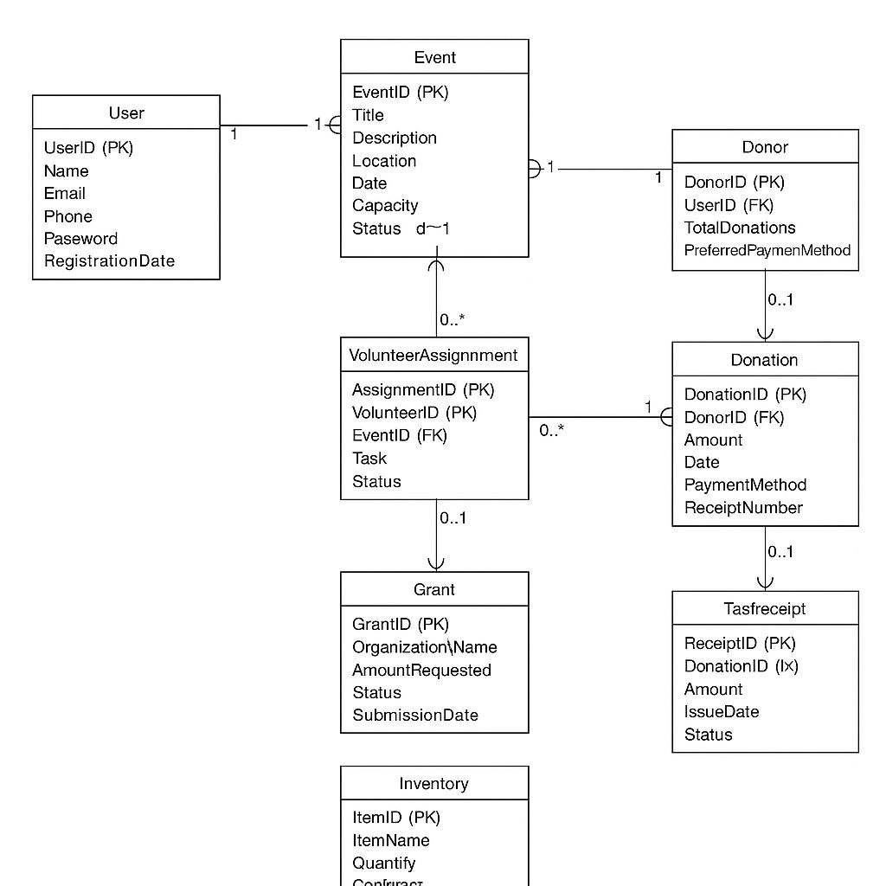

**Content Plans**

Content plans for each page in your Nonprofit Management System Prototype.

**1.Homepage**

**Text:**

• A vision statement and welcome message.

• A brief description of the nonprofit's objectives and influence.

• A call to action, such as "Join Us" or "Donate Now."

**Features:**

• The navigation bar, which includes links to Impact Reports, Campaigns, Events, Volunteers, Donors, Grants, Staff, and Donations.

• Emphasised recent initiatives and campaigns.

• Success stories or testimonials.

**Input controls:**

• A form for registering for the event (name, phone number, email, and availability).

• RSVP buttons to participate in the event.

• A comment section for debates or suggestions.

2.**Events Page**

**Text:**

• Past and upcoming events with locations, dates, and descriptions.

• Information about how to sign up or take part.

**Features:**

• Filtering events (by location, category, and date).

• Countdown timers for events.

• A gallery of photos from previous occasions.

**Input controls:**

• A form for registering for the event (name, phone number, email, and availability).

• RSVP buttons to participate in the event.

• A comment section for debates or suggestions.

1. **Volunteer Page**

**Text:**

• A summary of volunteer positions.

• Testimonials and volunteer benefits.

**Features:**

• A list of volunteer positions that are open.

• Sorting options (by time commitment, region, or skills needed).

**Input controls:**

• Application form for volunteers (name, contact information, abilities, and availability).

• Role filters according on area and category.

• "Apply Now" buttons for fast registration.

1. **Donor Page**

**Text:**

• The significance of contributions and their effects.

• Important contributors are acknowledged.

**Features:**

• Donation figures, such as the overall amount of money raised.

• Donor list (optional, depending on privacy preferences).

**Input controls:**

• Donation form (amount, payment method, recurring donation option).

• Anonymous donation toggle switch.

• Message box for custom donation notes.

1. **Grant Application Page**

**Text:**

• A summary of the funds that are available and the requirements for eligibility.

• Deadlines for applications and a description of the procedure.

**Features:**

FAQ section and a list of grants with descriptions.

**Input controls:**

• The application form for a grant (name of applicant, organisation, proposal summary, and amount asked). • Uploading files for extra docs.

• To complete applications, click the "Submit" button.

1. **Impact Report Page**

**Text:**

• A summary of the nonprofit's achievements.

• Information and figures regarding the allocation of resources and endeavours.

**Features:**

• Interactive graphs and charts.

• Testimonials from beneficiaries and case studies**.**

**Input controls:**

• Drop-down filters (by impact kind, project, and year).

• A button to download complete reports.

• Public opinion feedback form.

1. **Campaign Page**

**Text:**

• An explanation of previous and current fundraising initiatives.

• Objectives, due dates, and achievements.

**Features include:**

• Progress bars for donations.

• A shown slideshow or promotional video.

**Input controls:**

• The form for campaign donations (amount, frequency, and mode of payment).

• The ability to join up as a volunteer for campaign-related tasks.

• Buttons for sharing on social media.

1. **Donation Confirmation Page**

**Text:**

• Confirmation information and a thank-you note.

• Details of receipts and tax deductions.

**Features:**

• Donation summary with reference number.

• The option for social sharing (such as "Share Your Support").

**Input controls:**

• The button to download the receipt.

• A feedback form that rates the experience of donating.

• A checkbox to subscribe to updates.

**Prototypes**

Utilising expertly designed mock-ups for the use cases of "Volunteer Registration" and "Donor Contribution.

**1. Volunteer Registration Screens**

Screens to Design:

1. Form for Volunteer Registration

• Name, Email, Phone, Address, and Event Selection Fields

• Buttons: "Submit Registration," "Cancel"

• Validation: Missing field errors

1. Confirmation of Registration

• "Thank you for registering!"

• Volunteer details summary

• "Return to Home" button

**2. Donor Contribution Screens**

Screens to Design:

1. Donation Page

• Fields: Name, Email, Payment Method, Donation Amount (preset + custom)

• Buttons: "Cancel," "Donate Now"

1. Processing payments

• loading animation, if any

• A status message, such as "Your donation is being processed."

1. Confirmation of Donation

• "Thank you for your contribution!"

• Details of the receipt

• "Download Receipt" button

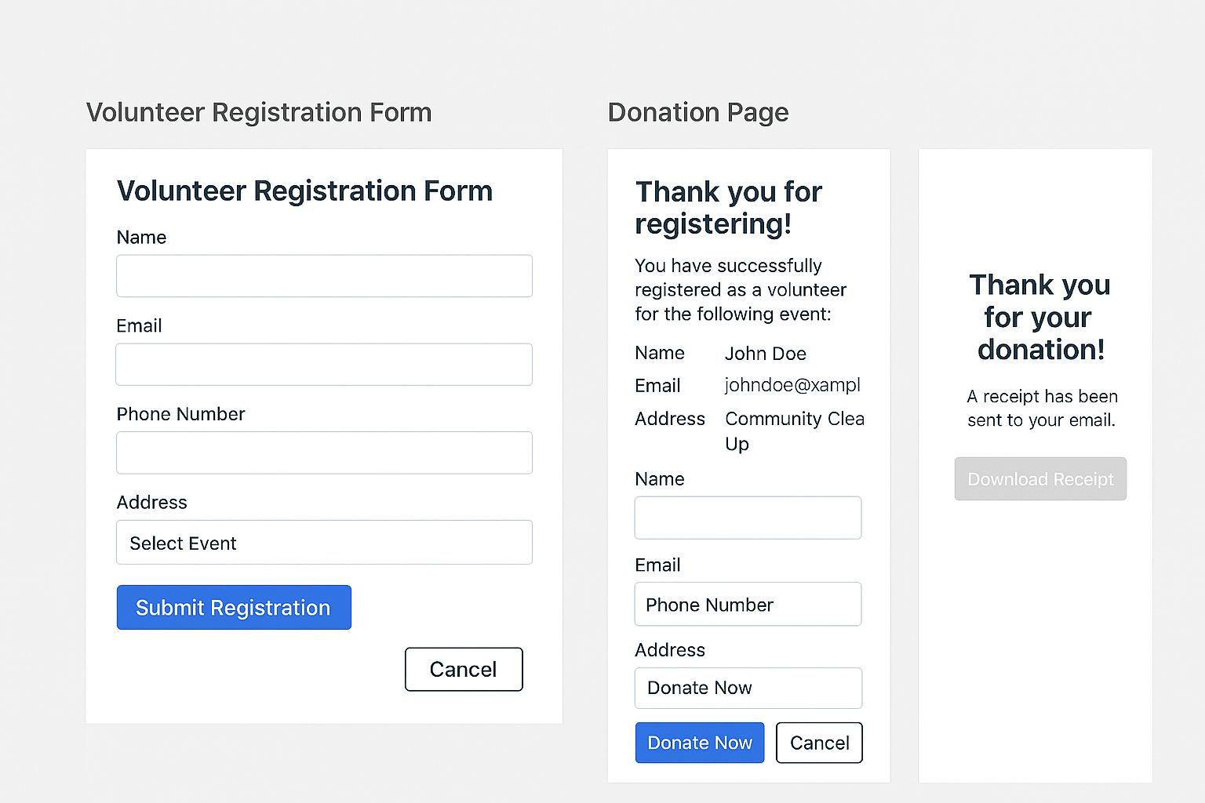 **Class Diagram**

I'll use Mermaid syntax to develop a UML class diagram for a nonprofit organisation management system. Classes with properties, methods, visibility indicators, associations, and inheritance will all be a part of this design.

Nonprofit Organisation Management System that addresses important topics like grant applications, volunteer coordination, event management, and donor monitoring.

Relationships & Classes:

1. User (Class Abstract)

Methods: +Login (), +Logout (); attributes: +User ID, +Name, +Email, #Password

• Bequeathed by the administrator, volunteer, and donor

1. Admin (inherited from User)

• Methods: +Manage Events (), +Approve Grants (), +Manage Users ()

• Attributes: +Role, +Permissions

1. Volunteer (bequeathed by the user)

• Qualities: +Availability, +Skills +Sign Up for Event () and +Update Profile () are the methods. Event (many-to-many) is the association.

1. Donor (Descended from the User)

Features:

+Preferred Cause, +Donation History

• Techniques: +View Impact Reports (), +Make Donation ()

• Associated with: One-to-many donations

1. Event;

Methods: +Register Volunteer (), +Update Event Status ();

Association with: Volunteer (many-to-many); Attributes: +Event ID, +Title, +Date, +Location, +Status

Donation

• Methods: +Process Payment (), +Generate Receipt ()

• Association with: Donor (many-to-one)

• Attributes: +Donation ID, +Amount, +Date, +Payment Method

1. Grant Application Methods:

+Submit Application (),

+Review Application (); Association with: Admin (one-to-many); Attributes: +Application ID, +Organization Name, +Requested Amount, +Status

**Important Elements of the Diagram:**

✅ Admin, Volunteer, and Donor are subclasses of the abstract class User.

✅ Volunteers (many-to-many relationship) at events; donors (one-to-many relationship); and administrators (one-to-many relationship) evaluate grant applications

✅ Public (+), Protected (#) visibility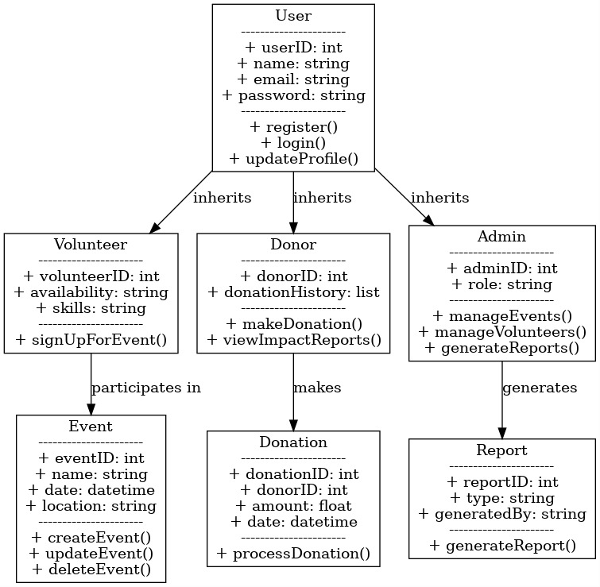.

**Implementation – Developing the Agile Plan**

**Agile Scrum Implementation Plan**

The Nonprofit Organisation Management System is being developed using the Scrum process, which consists of three sprints, each lasting three weeks. Every sprint provides a set of functional features with room for modification in response to user input or additional specifications.

**Components of the Scrum Framework**

1. **Duties:**

• Product Owner: Establishes project objectives and sets backlog priorities.

• Scrum Master: Removes obstacles and guarantees Scrum best practices. Features are designed, developed, and tested by the development team.

1. **Sprints:**

• Sprint 1 (Weeks 1-3): User registration, authentication, and core system setup.

• Sprint 2 (Weeks 4-6): Adding more functionality (donations, event management).

• Sprint 3 (Weeks 7-9): Improving deployment, testing, and functionality.

1. **Adaptability:**

• Agile makes it possible to adjust to schedule modifications or client feedback.

• Rapid problem solving and ongoing progress are guaranteed via iterative development.

**Spreadsheet Design**

The given spreadsheet has the following:

• Sprint number and duration;

• Primary focus and goals;

• User stories and features created during each sprint; • Expected deliverables at the conclusion of each sprint;

• Status monitoring to track advancement



This is Scrum methodology in Agile development diagram.

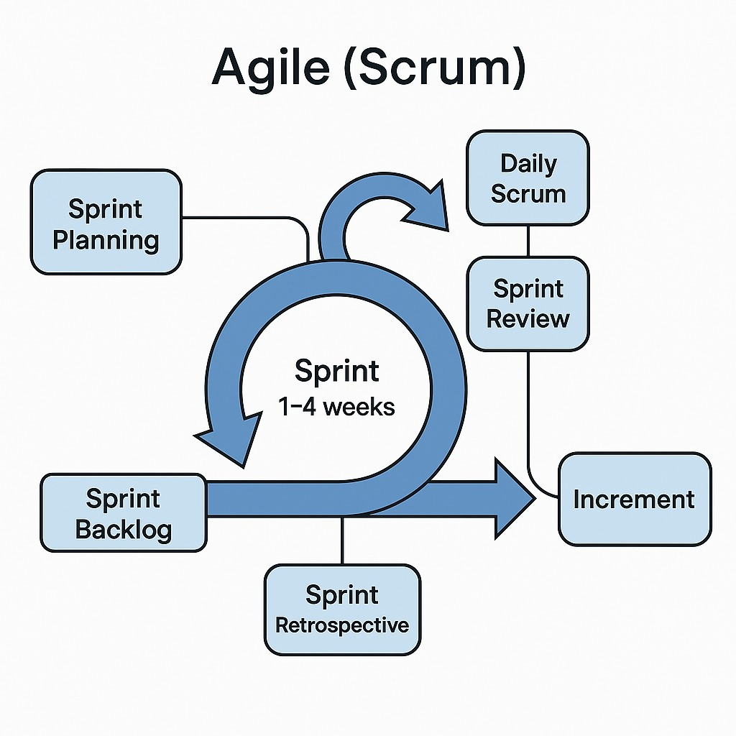

Important Scrum Components in the Diagram:

1. Sprint Planning:

This phase establishes the goals for each sprint.

• This would involve choosing user stories for your project (e.g., volunteer registration, donor contributions).

1. Sprint Backlog:

• A list of features and tasks that need to be finished in a sprint.

• Processing donations, event management, and authentication are all included in your backlog.

1. Sprint (one to four weeks):

• A set time frame for developing specific backlog items.

• There are three 3-week sprints in your project.

1. Daily Scrum:

• A quick team-coordination meeting every day.

• Assists in identifying obstacles and monitoring progress.

1. Sprint Review:

• At the conclusion of a sprint, showcasing finished work.

• Your group would present completed backend functionalities and user interface components.

1. Increment:

• Your system will have a working product by the conclusion of each sprint.

• The final working product at the end of each sprint.

This diagram fits your Agile plan for the nonprofit management system and does a good job of summarising how Scrum operates.

**Conclusion**

By combining crucial tasks like event planning, volunteer coordination, donation tracking, grant applications, and impact reporting into a single, intuitive platform, our nonprofit organisation management system is made to simplify operations for NGOs. We guarantee scalability, efficiency, and adaptability to the changing needs of charities by utilising cloud-based technologies and agile processes. This project shows our dedication to utilising contemporary software development techniques, such as Scrum methodology, collaborative cloud tools, and iterative development, in addition to showcasing our ability to envision, create, and prototype a digital solution.

Future developments might include predictive analytics for grant application success rates, AI-driven insights into donor involvement, and mobile-first changes to improve accessibility. In order to help charity organisations concentrate more on their goal and less on administrative difficulties, we plan to keep improving this platform.

**References**

1. <https://www.amazon.com/Complete-Guide-Nonprofit-Management/dp/0471380628>
2. <https://www.amazon.com/Managing-Nonprofit-Organization-Updated-Twenty-First-Century/dp/1451608462>
3. <https://www.amazon.com/Cases-Nonprofit-Management-Hands-Approach/dp/1483383482>
4. <https://www.amazon.com/Nonprofit-Management-Principles-Michael-Worth/dp/1544379986>
5. <https://www.bridgespan.org/insights/nonprofit-strategy-and-management-resources>
6. <https://www.classy.org/blog/11-tried-and-true-nonprofit-resources/>
7. [https://en.wikipedia.org/wiki/CiviCR](https://en.wikipedia.org/wiki/CiviCRM)
8. <https://en.wikipedia.org/wiki/Aplos_Software>
9. Nonprofit Learning Lab – <https://www.nonprofitlearninglab.org>
10. Bridge span Nonprofit Strategy Resources – <https://www.bridgespan.org/insights/nonprofit-strategy-and-management-resources>
11. Classy Nonprofit Learning Hub – <https://www.classy.org/blog/11-tried-and-true-nonprofit-resources/>
12. Kind full (Fundraising & CRM) – <https://kindful.com>
13. VolunteerHub (Volunteer Management) – <https://www.volunteerhub.com>
14. Asana (Project Management) – <https://asana.com>